** **

**PROJECT REPORT**

**Cook Book : Your Virtual Kitchen Assistant**

YEAR : **2024 – 2025**

COLLEGE NAME : **K.C.S KASI NADAR COLLEGE OF ARTS & SCIENCE**

CODE : UNM203

DEPARTMENT : **COMPUTER SCIENCE**

PROGRAM : **B.C.A Computer Application**

SEMESTER : **VI**

PROJECT SUBMITTED TO: UNIVERSITY OF MADRAS / NAAN MUDALVAN

Course Name : **Front End Development and Database Administration**

**TEAM LEADER: R CHRISTINA MARY**

**MEMBERS:**

1. N BAVITHRA

2. G UMAMAHESHWARI

3. S THIRISHA

**GUIDED BY: Mrs.R.PADMADEVI**

**SPOC NAME: Dr.K.** LALITHAKAMESWARI

**Cook Book : Your Virtual Kitchen Assistant(React Application)**

**Introduction to the Cookbook**

Cooking is a delightful blend of art and science, bringing joy to both the creator and the consumer. This cookbook is your ultimate guide to exploring the culinary world, offering a diverse collection of recipes that cater to various tastes and dietary preferences. Whether you're a seasoned chef or a kitchen novice, this book will inspire you to create delicious and memorable meals.

**Description of the Cookbook**

This cookbook focusing on different aspects of cooking. Here's what you can expect:

**1. Appetizers and Starters**

Begin your culinary journey with a variety of mouthwatering appetizers and starters. From simple finger foods to elegant hors d'oeuvres, there's something for every occasion.

**2. Main Courses**

Discover a wide range of main courses that cater to different tastes and dietary preferences. Whether you're vegetarian, or vegan, meat eater you'll find recipes to satisfy your cravings.

**3. Side Dishes**

Complement your main courses with an array of delicious side dishes. These recipes will add flavor and variety to your meals.

**4. Desserts**

Indulge your sweet tooth with a selection of delectable desserts. From classic cakes and cookies to innovative treats, these recipes will satisfy any dessert lover.

**5. International Cuisine**

Explore the flavors of the world with recipes inspired by various international cuisines. This section will take you on a culinary journey, introducing you to new ingredients and cooking techniques.

**6. Nutritious**

For those who are health-conscious, this section offers recipes that are both nutritious and delicious. You'll find balanced meals that are packed with flavor and good for you.

**Features of Cook Book:**

* **Organized**: Structure of the cookbook is easy with navigable sections with consistent recipe formatting.
* **Clear Instructions**: step-by-step guides that are easy to follow and simplify complex tasks.
* **Key Ingredients**: Detailing the origin and benefits of ingredients, and suggest alternatives for versatility.
* **Include Visuals**: the cookbook is included with high-quality photos and illustrations to guide and inspire readers.
* **Test and Refine**: All recipes are thoroughly tested and refined based on feedback for consistent results.

**Project Structure:**

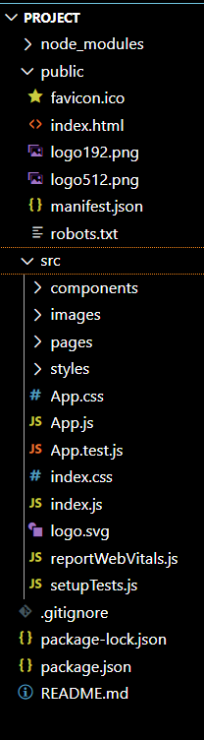 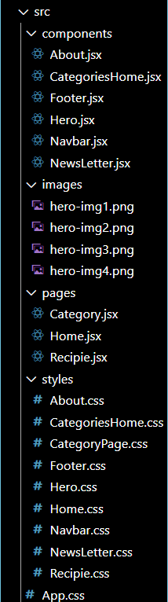

**Project Exceution:** here are the screenshots of the website along with their various recipies

* **Main Page:**

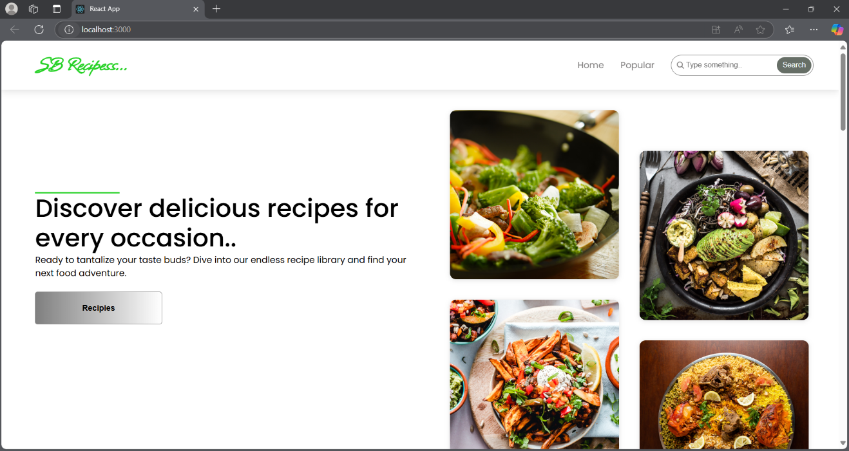

**This is the homepage of the website displaying the food images along their option of recipes**

* **Categories:**

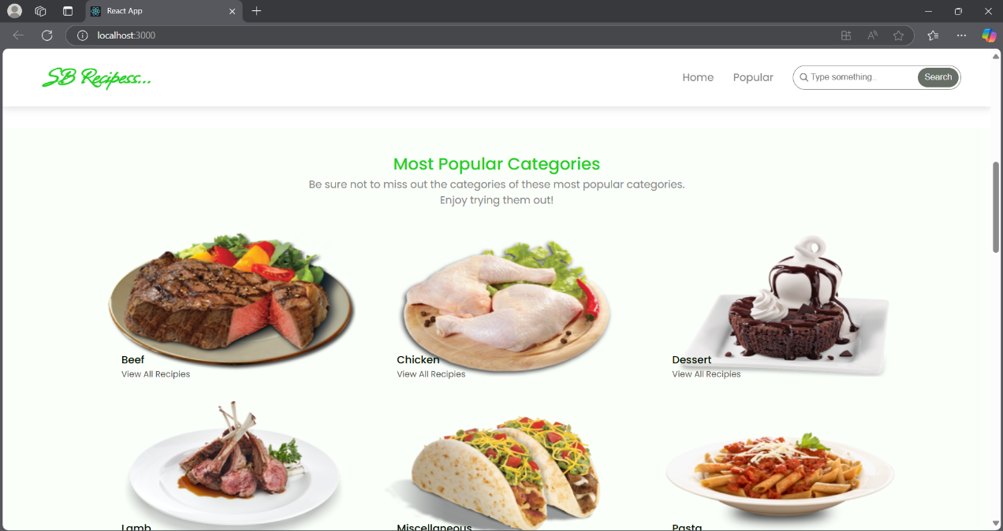

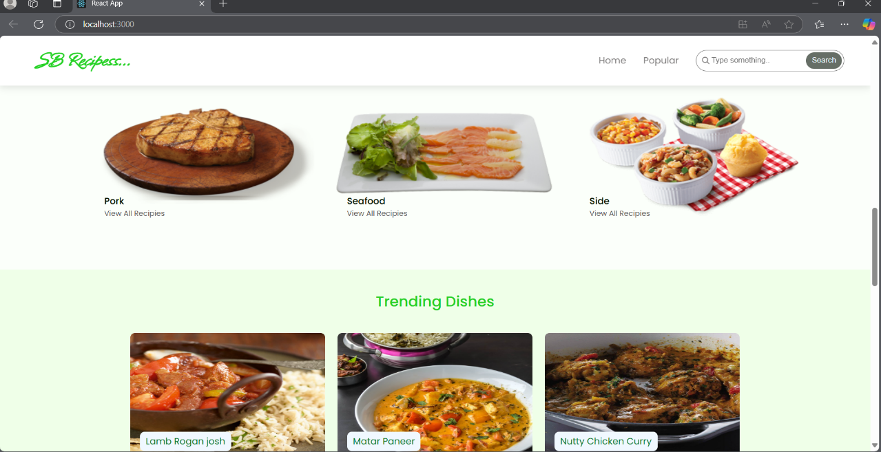

**This categories provide the insight of the food which is avaliable and the wide number of varieties to choose from.**

* **Newsletter:**

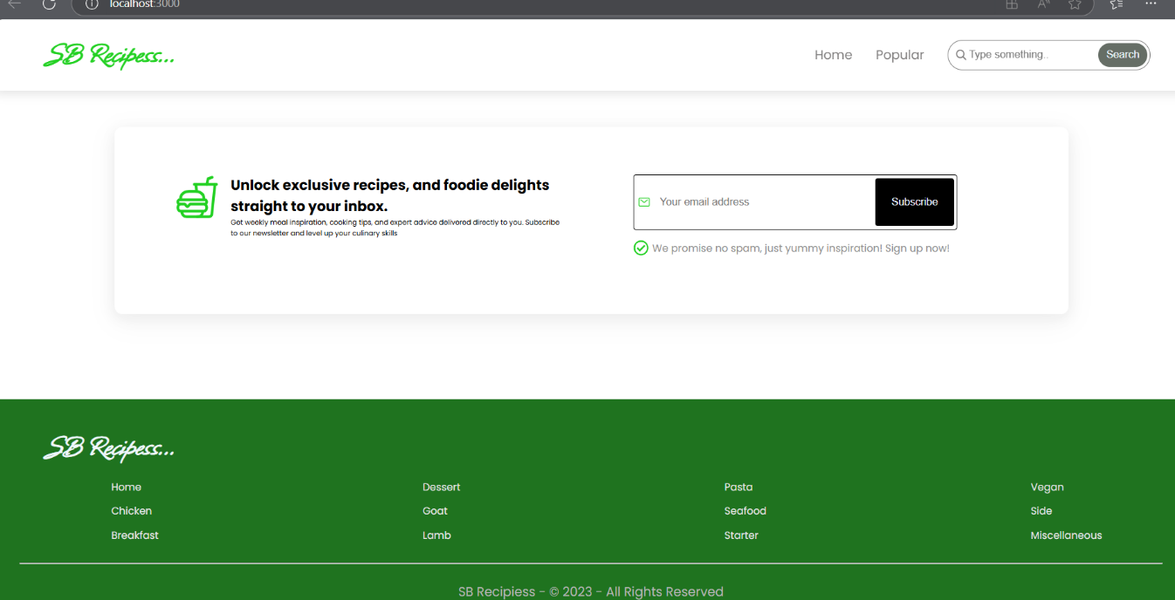

**This is the newsletter section for subscribing to the new information regarding the new recipies and wide varities of options.**

* **Detailed List of categories :**

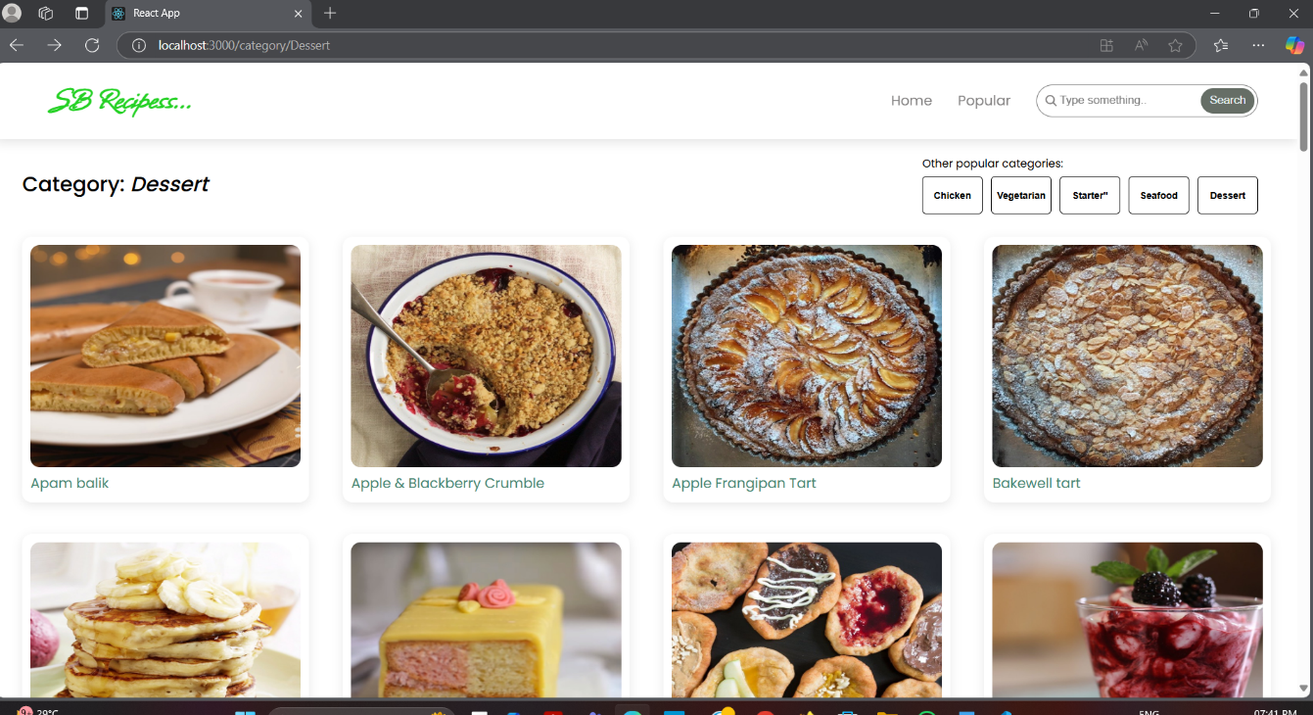

**This provides the detailed list of food recipies that are available in for our reference**

* **Recipie pages:**

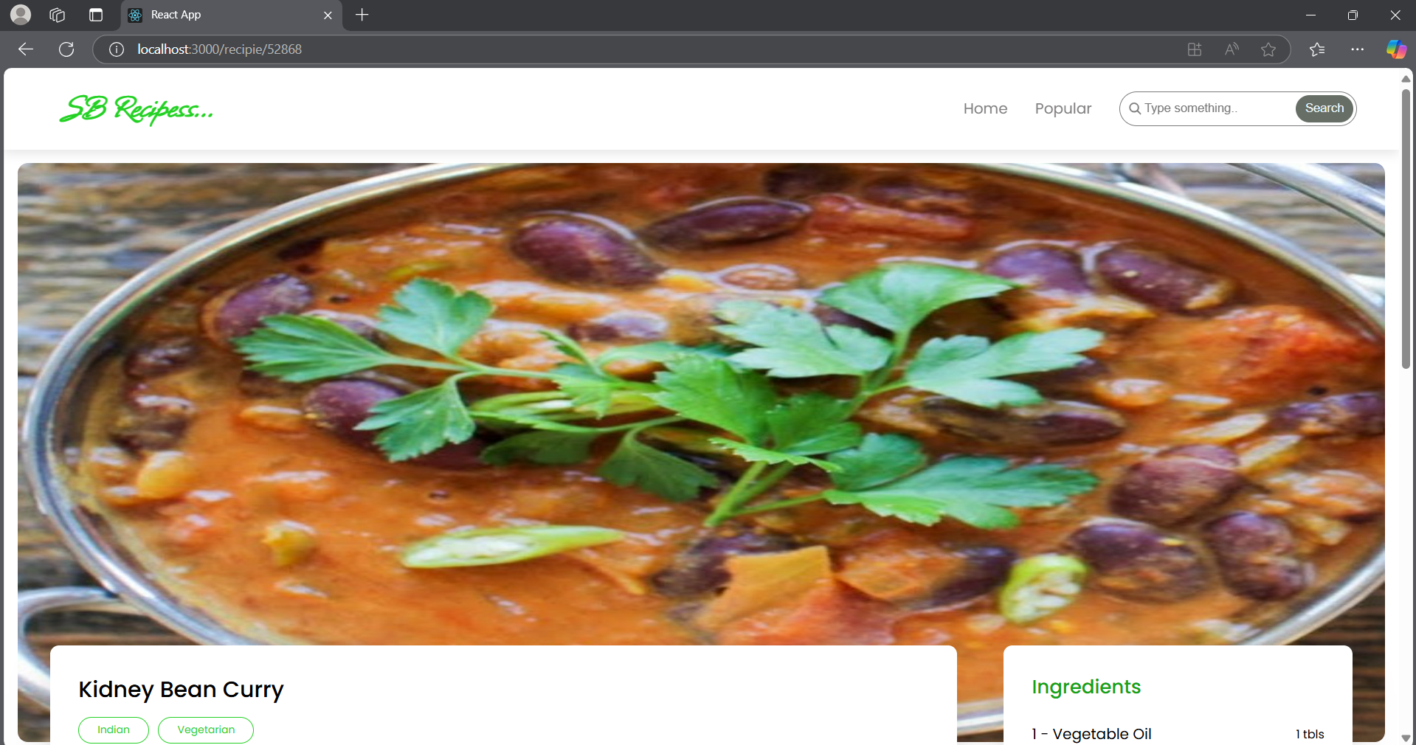

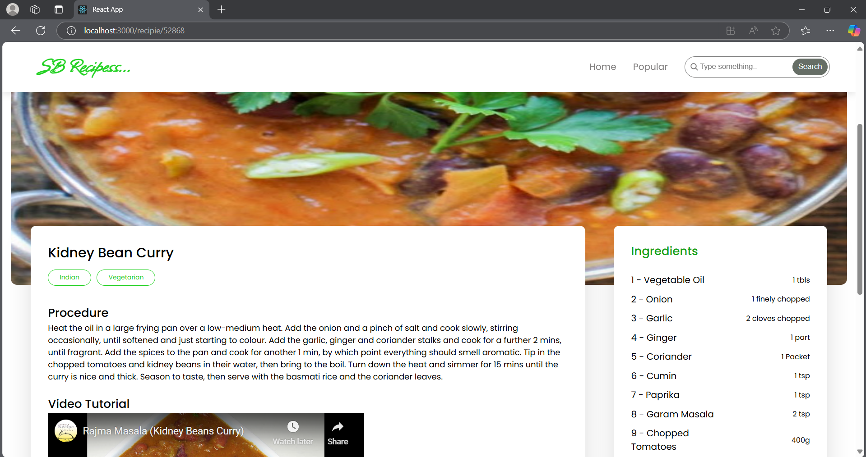

**This is the section which provides the detailed recipe of the given food catalog for each of the dish which is displayed in the categories.**

* **Wide varieties:**

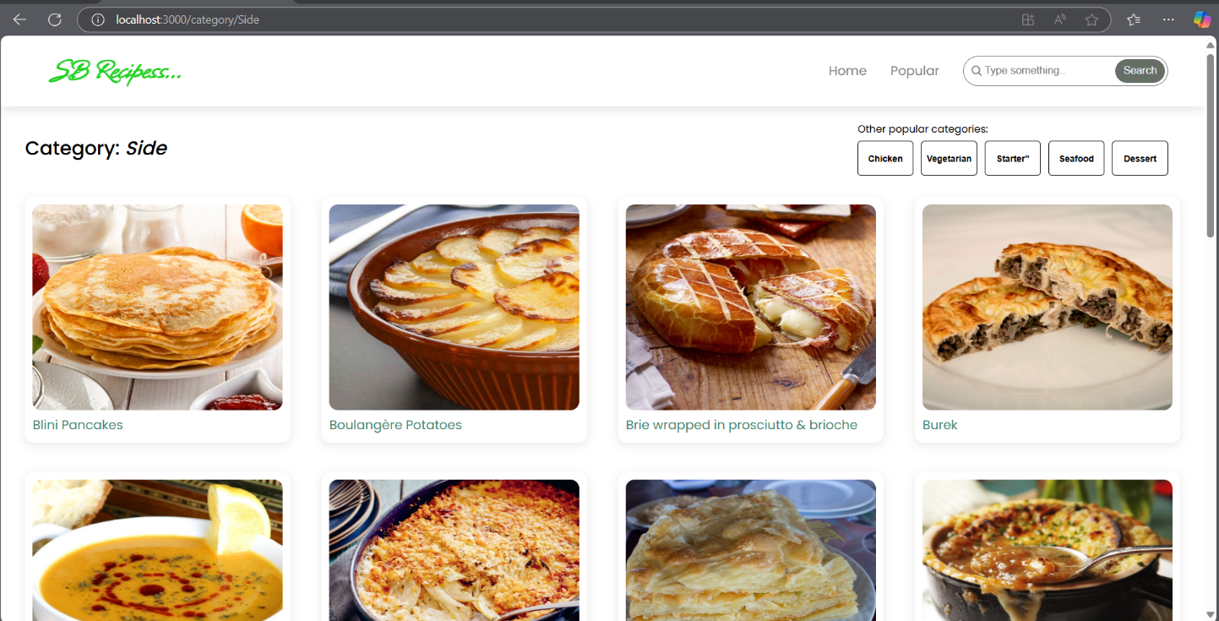

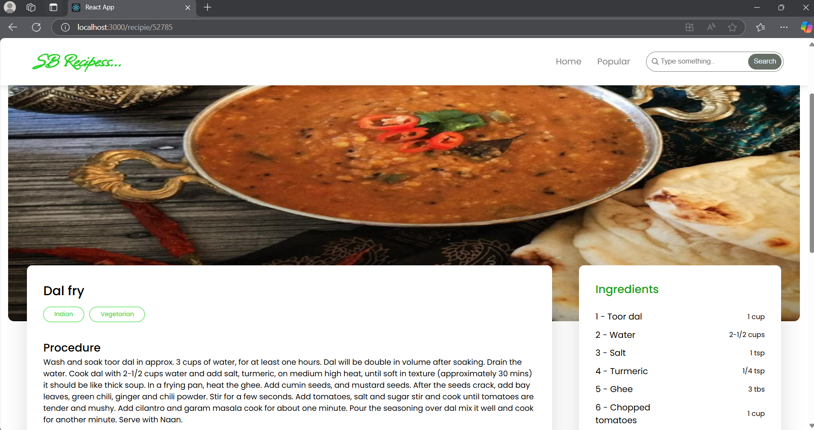

**This is another example of the given wide variety of recipes to choose from and to cook .**

**Project Demo Link:**

**https://drive.google.com/file/d/1ommy4v98BlLmBWxZuujY5q_NmzRkF2yN/view?usp=drivesdk**